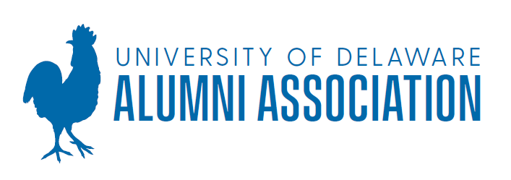
Academic Enrichment Award • 2024-2025

Academic Enrichment Awards were created by the UD Alumni Association (UDAA) in 2001 to provide, through financial assistance, an opportunity for students to enrich their education at the University of Delaware. In 2011, the criterion for funding was updated and only legacy students are eligible to receive funding. Legacy is defined as a student whose parent or step-parent who is a UD graduate. Preference is given to first-time applicants, undergraduates and students who have found other funding sources. Up to $2,000 per student may be awarded to allow a student to take part in an opportunity in which he/she may not otherwise be able to participate. These opportunities to enrich the UD experience may include, but are not limited to, academic competitions, symposia, conferences, leadership programs or other academic endeavors.

Examples of recent programs receiving individual awards include:
- Performing at the Chamber Music Festival in Bastad, Sweden.
- Presentation of research at the International Conference of the Book in Madrid.
- Receiving an award at Music Teacher’s National Association Conference.
Students with an overall grade point average of 3.0 or above are eligible to apply. Receipts must be submitted for all money received. No portion of the award may be used for alcohol. Study abroad programs without additional discovery, research or service-learning opportunities are not eligible. Activities in locations with a Level 3 or 4 travel warning as seen on the US State Department’s travel warning page are not eligible.
Please refer to the AEA website for a full description of funding criteria and guidelines.
Applications will be considered two times during the 2023-2024 year, according to the following schedule:
Apply by: | Notified via email by:
November 1, 2024 | December 1, 2024
March 1, 2025 | March 31, 2025

Funds are limited so applicants are encouraged to apply at the earliest possible deadline.

To apply for the Academic Enrichment Award, complete the attached application and submit it along with:
- An essay, not to exceed two pages, explaining why you are a good candidate for this award, detailing your legacy connection and what your UD legacy connection means to you.
- Include, in essay or otherwise, a detailed description of the program, conference, competition, etc. for which you wish funding and indicate the dollar amount you would like to receive ($2,000 maximum per student per year).
- Include detailed documentation that verifies the cost of the program (i.e. website printouts, travel agent quotes, mileage estimates for gas costs from website, etc). The committee needs to see how your costs are calculated and where the estimates came from. An expense form is included in the application to help you calculate the amount of your request.
- One letter of reference from your faculty advisor or a member of the UD community who endorses your proposal and how you would use the award. Reference letters from outside UD may be submitted as additional support.
- An unofficial or official copy of your transcript.
The UDAA carefully reviews every application for an Academic Enrichment Award in accordance with the above criteria. As funding is limited, all eligible individuals may not receive an award. The decision of the AEA Committee as to whether to grant an award is final. The UDAA reserves the right to determine the criteria for awarding AEA funding.

Questions? Contact the Alumni Association via email at alumni-association@udel.edu.
Academic Enrichment Award Application • 2023-2024

Applicant’s Name_______________________________________________________________

Provide the general nature of program_______________________________________________

______________________________________________________________________________

Date(s) of program: _________________ Amount requested $________ Overall GPA _________

Birth date___ /___ /___ Undergrad. Student □ Graduate Student □ Expected Grad Year______

Major(s) _______________________ Minor(s) ________________________ College________

Permanent Address______________________________________________________________

City _____________________________________ State ______________ Zip______________

Home Phone ( ) _____________ Local Phone ( ) _____________ E-mail_______________

Reference Name ___________________________________ E-mail_______________________

List the full name(s) and graduation year(s) of your family members who are UD graduates – NOTE: this list must include at least one parent or step-parent to be eligible for funding & please include an email address for your parent(s):

Have you previously received an Academic Enrichment Award? Yes No
If yes, date(s) of award(s) and amount: ___________________________ Month, year & amount

Application checklist (in addition to this application and expense form):
□ Essay □ Program Description □ Cost documentation □ Reference letter □ Transcript

I verify that all information in this application is valid. I release the UD Alumni Association from any liability regarding all aspects of the program for which I am applying, and I authorize the UDAA to contact the Office of Judicial Affairs to review my disciplinary records, if any.

Signature: ____________________________________________ Date: ___________________

Return the application and required attachments to:
UDAA Academic Enrichment Award • alumni-association@udel.edu
Preferred format is one PDF emailed all together.

