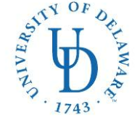
COLLEGE OF HEALTH SCIENCES—Dept. of Behavioral Health & Nutrition
MS IN NUTRITION & DIETETICS/DIETETIC INTERNSHIP (MS/DI)
26 N. College Ave
023 Carpenter Sports Building
Newark, DE 19716
Ph: (302) 831-3538 Fax: (302) 831-4261
E-mail: bschwenk@udel.edu

Application Checklist:
University of Delaware MS in Nutrition & Dietetics/Dietetic Internship

- Local Option: Please rank your county preferences below. If you are only interested in one county, indicate your first choice only.
____ New Castle County
____ Kent County
____ Sussex County
- Distance option

❒ DICAS application submitted online

Applicant’s name (please print) Applicant’s Signature

E-mail address
( )
Phone number State of Residence

